* Hit getEmployee and generate response, validate the response if it have the name which added in our earlier addEmployee.

//1. go to the getEmployee and get the property value for Request.

def getReq=testRunner.testCase.testSuite.testCases["getEmployee"].testSteps["get"].getPropertyValue("Request")

//2. load the request xml in XmlHolder.

def getEmpxml=new XmlHolder(getReq)

//3. put the value in correct xml node.

getEmpxml.setNodeValue("//typ:getEmployeeDetails/typ:employeeName",name)

//4. save the xml now

def newGetEmpXml=getEmpxml.getXml()

//5. place it back in the set property.

testRunner.testCase.testSuite.testCases["getEmployee"].testSteps["get"].setPropertyValue("Request",newGetEmpXml)

//6. now reach get service test step control

def getTestStep=testRunner.testCase.testSuite.testCases["getEmployee"].testSteps["get"]

//we have to create a context specific to the test case. For that pass a test step beloning to the test case to WsdlTestRunContext()

def contextGetEmployee= new WsdlTestRunContext(getTestStep)

getTestStep.run(testRunner,contextGetEmployee)

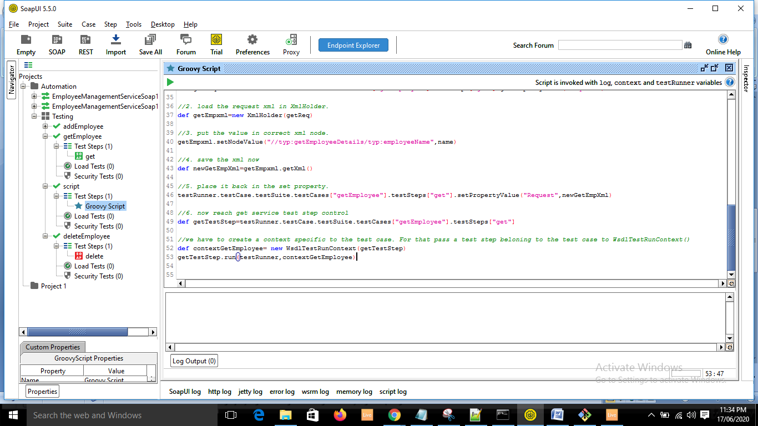

* Now we need to check the one entered in add is same as the get.